**Kol simcha torah gazette**

**For parshas vayakhel 5784**

Volume 8 Issue 26 (Whole #384) 29 Adar Rishon 5784/ March 8, 2023

**Printed L’illuy nishmas Nechama bas R’ Noach, a”h**

For a free subscription, please forward your request to [***keren18@juno.com***](mailto:keren18@juno.com)

***Past emails can be found on the website ShabbosStories.com under Brooklyn Torah Gazette***

**How to Deal with the**

**Dreams in Your Life**

**By Daniel Keren**

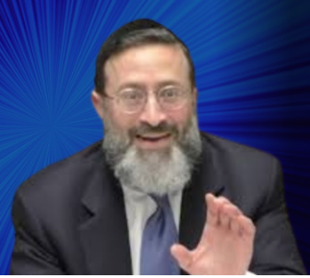

**Rabbi Eytan Feiner**

One of the featured speakers at the recent Presidents Day Flatbush Hakhel Yarchei Kallah Event was Rabbi Eytan Feiner, rav of Congregation Knesseth Israel – the White Shul in Far Rockaway. The topic of his lecture was “The World of Dreams in Halacha and Machshava.”

Rabbi Feiner began his shiur with an outstanding October 7th Dream and a fascinating Rav Yitzchok Zilberstein teshuvah. In the early morning hours of October 7th, a baal teshuvah who was living in a Yishuv near the Gaza border had a dream in which his rosh hayeshiva was telling him to immediately get up and gather his wife and their two children and get into a car and drive away from his community to safety. Only that morning was both Shabbos and the Yom Tov of Shemina Atzeres, both days when Torah observant Jews are prohibited from doing certain melachos, including driving a car.

When he work up, he just shrugged it off as a dream and went back to sleep where he fell into a second dream when the rosh yeshiva again warned him even more harshly, even grabbing him by his neck and pleading that he was in great mortal danger and must flee the Yishuv. This time he awoke and confused he woke up his wife and told her of his two dreams and that they should immediately get into a car with their children and drive until they were safe.

**Realizing the Horrifying Truth of His Scary Dream**

After arriving at a community where he felt safe, he parked the car. A few hours later he and all of Israel realized that a terrible attack occurred many of his neighbors unfortunately were killed or injured that same day by Hamas terrorists yemach shemom.

After that terrible day and the Yom Tov ended the shaken baal teshuvah called his Rosh Yeshivah and told him about his startling dreams. He asked then even though the dreams had saved his life and the life of his wife and children, does he have to do teshuvah (repent) for the real sin of driving his car on a day that as mentioned before was both a Shabbos and Yom Tov. The Rosh Yeshiva felt that he needed to pass the shailah (question) to another rabbi and he chose to forward the query to Rav Yitzchok Zilberstein, the brother-in-law of the late posek hador – Rav Chaim Kanievsky.

Rav Zilberstein responded by explaining that had the dream turned out to not be true, yes the baal teshuvah would have to repent for following a false dream interpretation. But since the dream was accurate, he had not sinned. But he was correct in driving only so far as he felt he needed to go to in order to be safe and not to do any more desecrations of Shabbos and Yom Tov. Rabbi Feiner also noted that Shabbos, the day in which the baal teshuvah had his dream is 1/60th of Olam Habah (the World to Come) and that sleep itself is 1/60th of Misa (death).

**The Difference Between Dreams**

**of the Past and the Future**

In analyzing dreams, Rabbi Feiner said that most dreams that we have are focused on the past and for those type of dreams, we don’t have to be concerned. If, however, the dream focuses on something that will occur in the future, we have to take it seriously as dreams are 1/60th of prophecy.

Rabbi Feiner also said that if a dream occurs on Shabbos or on Rosh Hashanah, one has to take such a dream more seriously. Other points he mentioned include a reference to a statement of the Rif (Rabbi Yitzchak ben Yaakov Alfasi, 1013-1103, a Moroccan Torah scholar,) who writes that Hakodesh Baruch Hu often opts for a dream to be a messenger.

Other topics that Rabbi Feiner touched was why did Hakodesh Baruch Hu create us with a need to sleep or to dream or to have nightmares? He also discussed about dreams that are recorded in Tanach (the Jewish Bible.)

*Reprinted from this week’s edition of The Flatbush Jewish Journal.*

**Rav Avigdor Miller on**

**Marrying a Nice Girl Who Cannot Hold a Conversation**

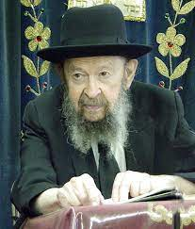

**QUESTION:** I am meeting a nice girl who has yiras Shamayim but she cannot holda conversation. Should I continue with the shidduch?

**ANSWER:** I would say you should grab her before somebody else gets her.

A woman came to me. She was fighting with her husband and she told me, “The trouble in my marriage is that there’s no communication between me and my husband.” I said to her, “There’s too much communication between you and your husband.”

That’s why they’re arguing all the time. Stop arguing! Stop with all that communication! Just keep quiet and everything will be alright. Communication is the trouble, not the solution.

A girl who doesn’t make good conversation, if she’s a normal girl – that you have to find out, if she’s a normal girl – the fact that she can’t hold a good conversation? Very good!

*Reprinted from the Parshas Ki Sisa 5784 email of Toras Avigdor*

*.*

**The Inner and Essential Connection of the**

**Sanctuary and Shabbos**

**From the Teachings of the Lubavitcher Rebbe**

**Rabbi Menachem Mendel Schneerson, Zt”l**

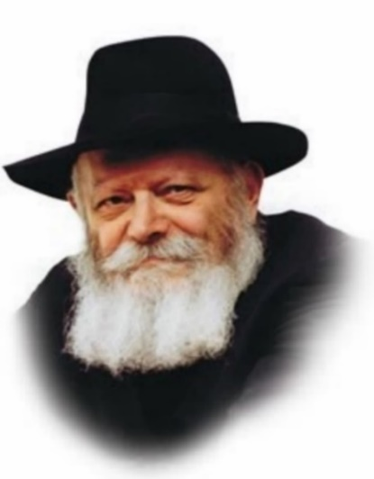

While the last few Torah portions contained detailed instructions on how to erect the Sanctuary, Vayakhel interrupts the sequence and introduces a whole new topic.

In the beginning of Vayakhel, Moses gathers the Jewish people together and conveys to them G-d's command to keep the Sabbath: "Six days shall work be done, and the seventh day shall be holy, a Sabbath of rest to G-d."

As the Talmud explains, from the juxtaposition of this commandment we learn which types of labor are forbidden on Shabbat. These are the 39 categories of work that were required to build the Sanctuary.

Nothing in the Torah is coincidental. Every verse, word, letter and diacritical mark is intentional and significant. It is therefore obvious that an inner and essential connection exists between the Sanctuary and the Sabbath.

**Derived from the Tasks**

**Needed for Building the Sanctuary**

The 39 categories of labor prohibited on Shabbat are the "principles" - the root or source - of all the different types of work we perform in our daily lives. Everything that exists in the physical world is derived from its spiritual source. Every action and deed we perform throughout the week is therefore derived from the particular tasks that were involved in building the Sanctuary.

Yet in the same way that the Sanctuary is the source of all our physical labors, it is also their ultimate objective. The actions we perform on a daily basis may be simple and mundane, but their inner purpose is to bring sanctity into the material plane and establish a dwelling place for G-d in the physical world.

**“Man is Born to Toil”**

The Torah commands us, "Six days shall you work," which our Sages interpreted as a positive mitzva. In other words, working is not an option but an obligation, as it states, "Man is born to toil." It is for this reason that our prayers on weekdays are shorter than on Shabbat, i.e., so as not to interfere with our ability to work. G-d wants us to transform the world into a "Sanctuary" to Him through our exertion and effort.

How are we to do this? The Torah provides the answer: "In all your ways you shall know Him." Even our simplest and most mundane actions must be suffused with the knowledge of G-d. Everything we do - from eating and drinking to earning a livelihood - should be viewed as an integral part of our Divine service.

Although it was readily apparent that the Sanctuary was the place where the Divine Presence dwelt, the entire world has the same potential for transformation. Man's task is to bring this potential to fruition, by utilizing every minute for positive good deeds and actions.

*Reprinted from the Parshat Vayakhel-Pekudei 5761/2001 edition of L’Chaim Weekly. Adapted from Volume 1 of Likutei Sichot.*

**Rabbi Berel Wein on**

**Parshat Vayakhel 5784**

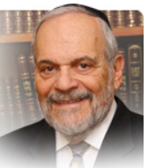

One of the main questions raised by the commentators to this week's parsha is why the Torah again discusses the prohibitions of the Sabbath. The Torah has done so in the previous parshiyot of Shemot, so one might question this seemingly unwarranted repetition. In their comments, I feel one of the ideas presented to be especially relevant to our world.

We do not find that at the time of creation, the Torah sanctified any given place or location on the face of the earth. The entire idea of the uniqueness of the Land of Israel does not appear in the Torah until the time of our father Abraham. And there it appears as a promise of a homeland to Abraham's descendants without any mention of holiness or sanctification.

Holiness only appears regarding a place and location in the story of our father Jacob and his heavenly dream at Beit El. Already in the first section of the Bible, in the story of creation itself, we read that the L-rd sanctified time. "Therefore, did the L-rd bless the seventh day and sanctify it.”

Time is the holiest of all factors in human life. It is the one thing that, since creation, has been blessed, sanctified, and made very special. It is no wonder that the holiness of the Sabbath is emphasized in the Torah. In human behavior and thought, time is as important as wealth or location or the accomplishment of any human deeds. The Torah comes to warn us not to succumb to such a viewpoint or behavior pattern.

The holy Tabernacle, according to most commentators, was ordered and built after Israel sinned in the desert by worshiping the golden calf. These commentators saw this Tabernacle as an accommodation, so to speak, of Heaven to the human condition. People somehow require a tangible place of worship, a holiness of space and locality, something solid that can represent to them the invisible and eternal. The Tabernacle, in a sense, came to replace the necessity for a golden calf created by human beings.

The L-rd gave Israel detailed instructions how this Tabernacle and its artifacts should be constructed and designed. Even though holiness of space, location and of actual structure is necessary for human service of G-d, it must be done solely under G-d's conditions. There can be many designs to build a golden calf. To build a Tabernacle to G-d there can only be one ordained holy design and plan. Even when building a Tabernacle according to G-d's plan, the Jewish people were instructed and inspired to remember that holiness of time is always greater than holiness of place and of structure.

The Sabbath, which has accompanied us from the time of creation, takes precedence over all else except for human life itself. The Tabernacle and its succeeding Temples were all temporary and subject to the events of time. Even the holy Land of Israel disappeared from Jewish history for millennia. But the Sabbath never stopped accompanying the Jews wherever they lived and under whatever the circumstances. And this is why this lesson is drummed into us in the narrative of the Torah. How pertinent this lesson is in our time and in our environment.

Shabbat shalom.

*Reprinted from the current website of rabbiwein.com*

**Teacher Confiscations**

**By Rabbi Hillel Raskin**

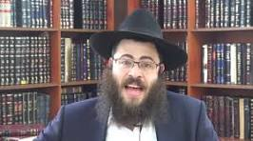

**Rabbi Hillel Raskin**

May a teacher confiscate an item from a student? According to halacha, a teacher may use corporal punishment to educate a student. It follows that he may certainly take something away from the student, as doing so doesn’t physically hurt him.

This is true even if the item is unrelated to the child’s specific misbehavior. This, however, doesn’t permit the teacher to destroy the item since that is not typically necessary for chinuch purposes, and it is forbidden to steal even from a child.

Thus, except for special situations where the item is physically or spiritually harmful or if chinuch warrants getting rid of the item, he may only confiscate the item temporarily.

What level of responsibility does the teacher have while holding onto the item? Is he obligated to pay if he loses it? An unpaid guardian is exempt for losing the item, while a paid guardian is responsible to pay.

While some suggest that a paid teacher is considered a paid guardian, the consensus is that he is an unpaid guardian since his payment is only for teaching the students and not for watching the confiscated item.

When punishing a student, the teacher should endeavor to minimize the student’s loss of learning time, particularly if it can cause the problem to escalate. Yet, if the child is disturbing other students, he should be sent out of class since the good of the majority outweighs this student’s personal loss of learning.

In general, Chazal teach that one should follow the approach of pushing away with the left hand and drawing close with the right hand. The Frierdiker Rebbe writes that using the staff often backfires, and much more could be accomplished through a pleasant and positively reinforcing approach. Even if screaming at the child has short-term results, this type of chinuch doesn’t produce the desired long-lasting results.

*Reprinted from the Parshat Ki Tisa 5784 edition of The Weekly Farbrengen. Rabbi Raskin is Rov of Anash in Petach Tikva, Israel.*

**Thoughts that Count**

Moses gathered all the congregation...and said to them: These are the words which the L-rd has commanded, that you should do them (Ex. 35:1)

As Rashi notes, this gathering took place on the day after Yom Kippur. On the holy day of Yom Kippur, everyone is in awe of G-d, suffused with a sense of peace and brotherly love for his fellow man. Moses gathered the Jews together immediately afterward to teach them that Jewish unity should not be limited to Yom Kippur, but should be felt throughout the year. *(Olelot Efraim)*

This is the thing which the L-rd has commanded to say...whoever is of willing heart, let him bring an offering...gold and silver and bronze (Ex. 35:4-5)

In his Responsa, Rabbi Shlomo ben Aderet (the Rashba) writes that "it is a mitzva to publicize and make known those who do a mitzva." It is therefore incumbent upon us to "say" - announce publicly - the names of whoever donates money for "the thing, which the L-rd has commanded." *(Pardes Yosef)*

Moses called Betzalel and Oholiav, and every wise-hearted man (Ex. 36:2)

Why didn't the "wise-hearted men" come on their own to Moses, and waited until he approached each of them individually? Because a person who is truly wise-hearted doesn't consider himself wise; when Moses issued his call, none of them thought he was talking to them. *(Ketoret Samim)*

*Reprinted from the Parshat Vayakhel-Pekudei 5761/2001 edition of L’Chaim Weekly.*

**A Family’s Dedication to Preserving Jewish Life Wherever They Live**

**By**[**Nancy K. S. Hochman**](https://www.chabad.org/search/keyword_cdo/kid/20474/jewish/Hochman-Nancy-KS.htm)

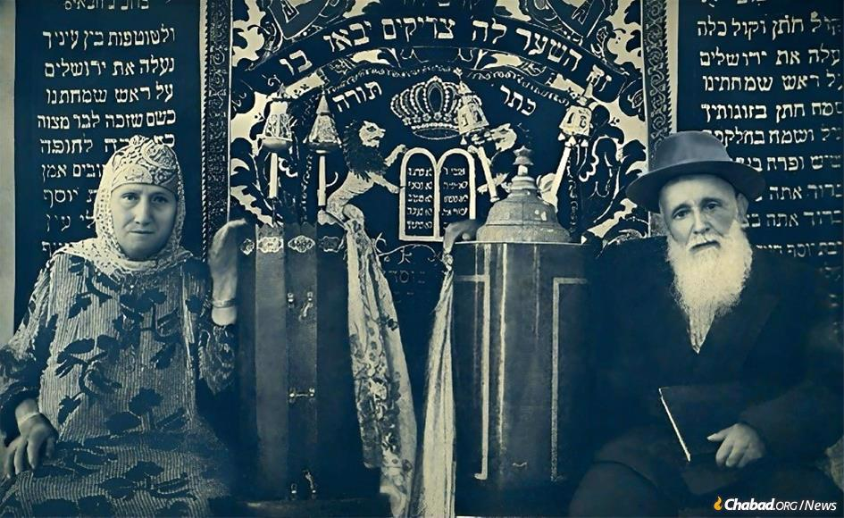

**Rahamim Shamash, right, and his wife with two Torah scrolls that he and his brother David brought from Jerusalem to Afghanistan in 1914.**

In 1914, Jewish Afghani brothers Rahamim and David Shamash returned from Jerusalem to Afghanistan along the well-trodden routes of the Silk Road with two new [Torah scrolls](https://www.chabad.org/library/article_cdo/aid/333007/jewish/What-Is-a-Torah-Scroll.htm), written for the Jewish communities of Afghanistan.

A century later, after falling into disuse and disrepair, one of the Torah scrolls has found a new home, when two scions of the [Shamash](https://www.chabad.org/holidays/chanukah/article_cdo/aid/1124/jewish/The-Lamplighter.htm) family—Hannah Zion and her brother, Ronald Abram—refurbished and rededicated it last month at [Chabad-Lubavitch of Hong Kong](https://www.chabad.org/jewish-centers/117857/Hong-Kong/Synagogue/Chabad-of-Hong-Kong).

“Our ancestors have supported Jewish worship wherever they lived and traveled,” Zion [told Chabad.org](https://www.chabad.org/news). “We want to show our own descendants and other young Jews living in Hong Kong the importance of maintaining Jewish life and tradition by connecting with the ancient [Torah](https://www.chabad.org/library/article_cdo/aid/1426382/jewish/Torah.htm) of the Jewish people.“

Additionally, through the story of her extended family’s challenges and triumphs around the world, Zion hopes that the rededicated Torah will serve as a living testament to “the strength and resilience of the Jewish people; their timeless devotion to Jewish tradition; and their ability to care for their own through times of both peace and persecution.”

That hope was also felt by Hannah and her husband Ephraim's grandson, Akiva Zion, who had the honor of reading from the centennial Torah the first day it was used in Chabad of Hong Kong. “When I touched the aged parchment, I felt a deep connection to Judaism, and Jewish tradition. In that moment, I knew I was honoring my family's history and sharing the wisdom of the Torah with the community, and one day, future generations. It was both a humbling and proud experience.”



**The scrolls were written in**[**Jerusalem**](https://www.chabad.org/library/article_cdo/aid/4246466/jewish/Jerusalem.htm)**and transported to Afghanistan in 1914, and sent to Tel Aviv in 1954. One was refurbished and brought to Thailand last year and the second to Hong Kong in 2024.**

**A Torah Scroll’s Long Journey From**

**Israel to Kabul to Israel to Hong Kong**

The Afghan Jewish community is ancient, dating back at least 2,500 years. A century ago, there were thousands of Jews living in the mountainous country, mostly clustered in the two cities of Kabul and Herat, until persecutions began in 1933. At the end of World War II, there were still 5,000 Jews living in the country, but almost all of them fled by the 1960s, with most emigrating to Israel.

When the Afghan synagogues in which the scrolls were housed closed in the early 1950s, the cousins’ grandfather and family patriarch, Rahamim Shamash, transported the Torahs to two Afghan synagogues:

Neve Yerushalayim and Yeshua V’Rahamim in southern Tel Aviv, where many Afghani Jews first relocated, said family member and historian Dr. Ofir Haivri.

But the two southern Tel Aviv synagogues eventually closed their doors when the Afghani immigrants moved to other areas in Israel.

Zina Abraham, Hannah and Ronald’s first cousin, succeeded in finding both Torah scrolls in storage in a synagogue in Holon, Israel.

**One of the Torahs was Donated to**

**The Even Chen Synagogue in Bangkok**

Upon gaining ownership of the Torahs, Abraham refurbished one of them, which she then donated to the Even Chen synagogue in Bangkok, Thailand, where her husband Yehudah and his brother Mayer established businesses, organized services and built a mikvah.

She left the other Torah in the trusted care of Hannah Zion. who along with her brother Ronald Abram moved to Hong Kong decades ago to maintain their father’s trading business after he passed away. Zion then had the letters of the Torah fixed under the steady hand of a New York *[sofer](https://www.chabad.org/library/article_cdo/aid/339595/jewish/Sofer-The-Torah-Scribe.htm" \o "Sofer: The Torah Scribe)* before she and her brother, who were both born in Afghanistan and spent the lion’s share of their childhood in New York, acquired a [cylindrical-shaped Sephardic Torah case](https://www.chabad.org/library/article_cdo/aid/3119530/jewish/Why-Do-Sephardim-Keep-Their-Torahs-in-Cylindrical-Cases.htm) that holds the Torah upright.

The siblings say they found inspiration for their communal work through their father. During Israel’s early years, when antisemitism in Afghanistan was raging, he helped fund the travel of Afghani Jews to Israel. He was also an adviser to the King of Afghanistan on Jewish affairs. Their mother also helped support, with help from neighbors and friends, the three Afghani yeshivahs that existed while she lived there.

Approximately 200 people, including family members who pray regularly at [Chabad](https://www.chabad.org/library/article_cdo/aid/244369/jewish/About-Chabad-Lubavitch.htm) of Hong Kong, celebrated the gift of the Torah last month. The siblings dedicated it to the memory of their parents, Shimon and Siporah Abram; their brother, Shmuel Abram; and Hannah’s grandson, Yehoshua Nathan Zion.



**Hannah Zion and her brother, Ronald Abram—refurbished and rededicated one of the scrolls last month at Chabad-Lubavitch of Hong Kong.**

**Among the First to Greet Chabad**

When Rabbi Mordechai and Goldie Avtzon opened the doors of C[habad of Hong Kong](https://www.chabad.org/jewish-centers/117857/Hong-Kong/Synagogue/Chabad-of-Hong-Kong) in 1986, Hannah Zion was among the first to greet them. She has been an involved and cherished member of the Chabad community ever since, seeing it grow from its humble beginnings to its expansion, which includes two satellite Chabad centers across the city that service Hong Kong’s more than 2,000 Jews from countries as far afield as Israel, France, Afghanistan and the United States.

“One of the beautiful things you can see in Hong Kong when it comes to a celebration or events is a sense of harmony and unity,” says Shay Ratzon, an Israeli who moved to Hong Kong in the year 2000 for business and attended the rededication ceremony last month.

**The Central Value of Judaism and**

**The Importance of a Sefer Torah**

Referring to the expansive history of the Zion-Abram ancestors and the many challenges they faced while helping myriads of Jews throughout Asia and the Middle East, [Ratzon](https://www.chabad.org/multimedia/video_cdo/aid/786166/jewish/The-Letter-Chaf.htm" \o "Secrets of the Letter Chaf) said: “You see the central value of Judaism, and the importance of a Sefer Torah in maintaining that central value. Regardless of the difficulties one faces, we can all come together as one.”

Jason Weber, who attended the ceremony with his wife, Dina, said “we were moved to see the Zion family rekindle their family legacy in the city in which they now live, perpetuating the memory of their ancestors and the Jewish people’s priceless inheritance, the Torah.”

**An Incredible Story of Jewish Continuity**

[Goldie Avtzon](https://www.chabad.org/2861391/), co-director of Chabad of Hong Kong, echoed that sentiment. “It’s beautiful to see the continuity of this special Torah from one generation to the next, and its journeys before arriving in Hong Kong,” she said.

Rabbi Avtzon agreed. “Here is a situation in which a person is fulfilling a pledge to ancestors not to exchange or forget about a Torah,” said the rabbi. “The fact that their descendants many years later are dedicating the very same Torah that their ancestors dedicated is an incredible story of Jewish continuity.”

*Reprinted from the February 27, 2024 posting on the Chabad.Org website.*

**Another Thought for the Parsha**

Of the hundred talents of silver were cast the sockets of the Sanctuary (Ex. 38:27)

The Hebrew root of the word for socket, "eden," has two meanings: 1) a base or doorsill, and 2) lord and master. Both meanings, however, are interconnected. This is alluded to in Rabbi Meir's statement in the Zohar: "He who is small is great; he who is great is small." A person who is as humble as a "doorsill" is truly noble, while one who lords himself over others and feels superior is truly lowly. *(Peninei HaTorah)*

*Reprinted from the Parshat Vayakhel-Pekudei 5761/2001 edition of L’Chaim Weekly.*